**Inequalities**

An inequality is a relation between two expressions that are not equal. The common inequalities that we work with are summarized below:

|  |  |  |  |  |
| --- | --- | --- | --- | --- |
| $$≠$$ | $$<$$ | $$≤$$ | $$>$$ | $$≥$$ |
| Not equal to | Less than | Less than or equal to | Greater than | Greater than or equal to |

**Linear Inequalities**

Linear inequalities involve two linear expressions. We have already solved basic linear inequalities when we covered domain.

For example, the domain of $f\left(x\right)=\sqrt{2x-3 }$ would be all real numbers such that $2x-3≥0,$ which results in $x≥\frac{3}{2}$.

Example 1: Solve the following linear inequalities.

$3x-4>2x+5$

$-3\left(x-2\right)≥\frac{1}{4}x+1$

**Compound Inequalities**

Compound inequalities express more than one inequality in a single statement.

For example, instead of stating $x>-2$ and $x≤6,$ we could combine these two statements to form the compound inequality $-2<x≤6$.

When working with compound inequalities, it is important to remember that you are manipulated more than one inequality at all times.

Example 2: Solve the following compound inequality.

$-3<6x+1<3$

**Polynomial Inequalities**

Polynomial inequalities involve two polynomial expressions. It is often easiest to compare a single polynomial expression to zero, and then think graphically.

Example 3: Solve the polynomial inequality and provide your solution in interval notation.

$2x^{3}-4x>3x^{2}-6$

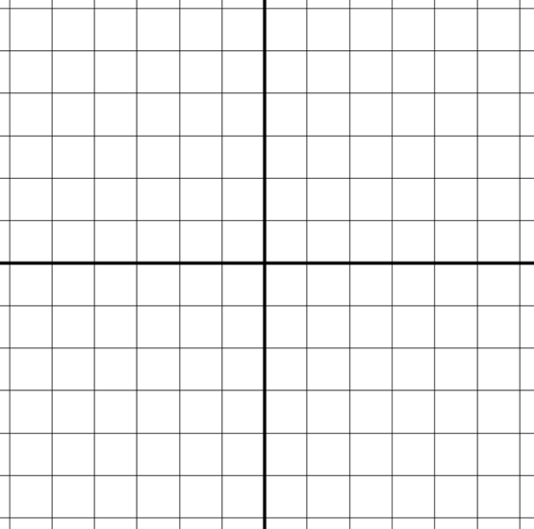

Example 4: Determine the domain of the radical function.

$q\left(x\right)=\sqrt{3x^{2}-4x-4}$

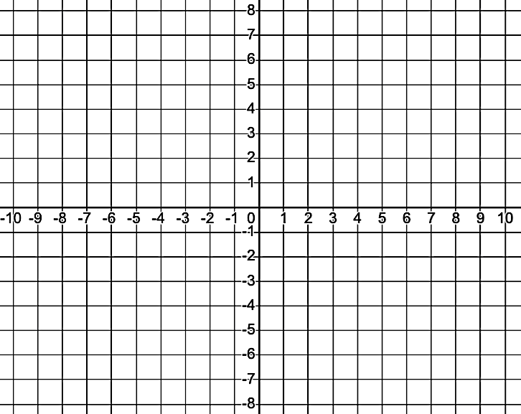

**Rational Inequalities**

Rational inequalities involve two rational expressions. Once again, it is often easiest to compare a single rational expression to zero, and then think graphically.

Example 5: Solve the following rational inequality

$\frac{2\left(x-3\right){\left(x+2\right)}^{2}}{(x+1)(x-2)(x+4)}>0$